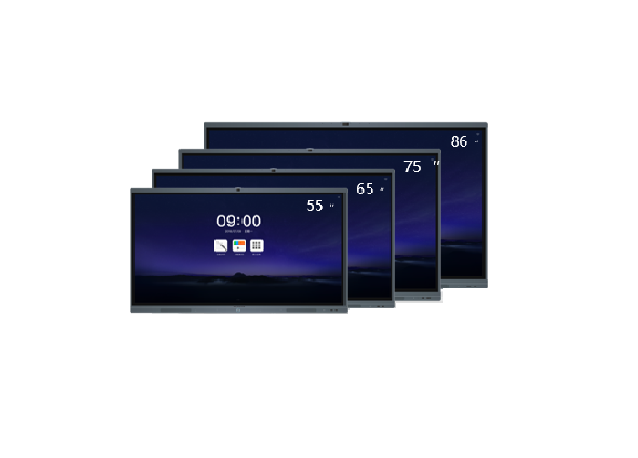
Brand:
DM
Model:
MH-S65FA

Weight in Kg:

90.0000

Image Sensor:
CMOS
Resolution
1920x1080
Brightness
350cd/m2
Dimension
1302x819x98mm
Color:
Black

