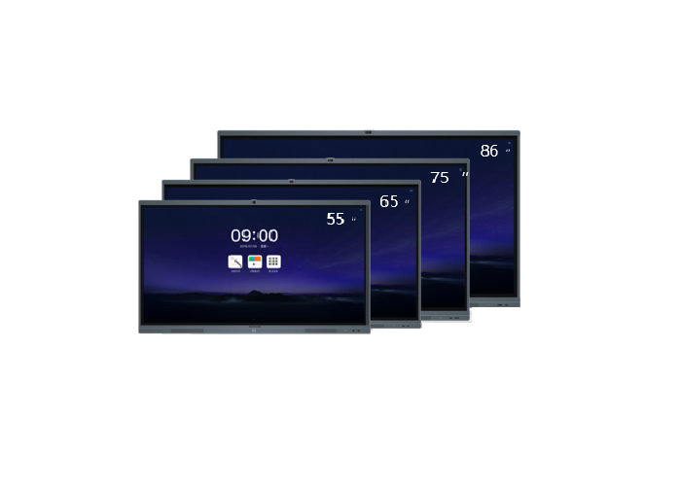**Brand:**

DM

**Model:**

MH-S86FA

**Weight in Kg:**

90.0000

**Image Sensor:**

CMOS

**Resolution**

1920x1080

**Brightness**

350cd/m2

**Dimension**

1302x819x98mm

**Color:**

Black